: How to monitor Veem Backup:
Login to the backup server i.e.
Click on the below icon on the desktop
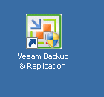
Click on History
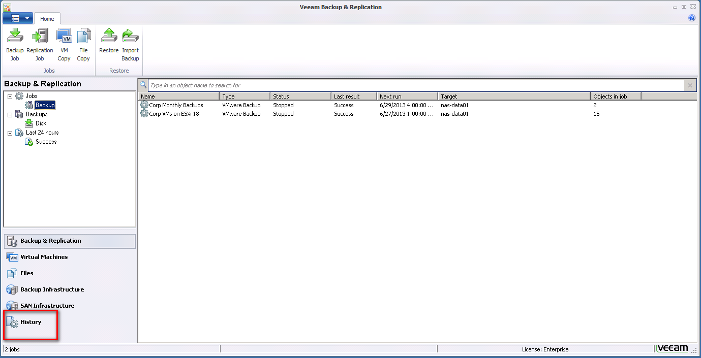
You have to monitor the Status as marked below.
If you see any error message then email client about this.
